QUICK INSTALLATION GUIDE FOR
AIR OBSTRUCTION LIGHT

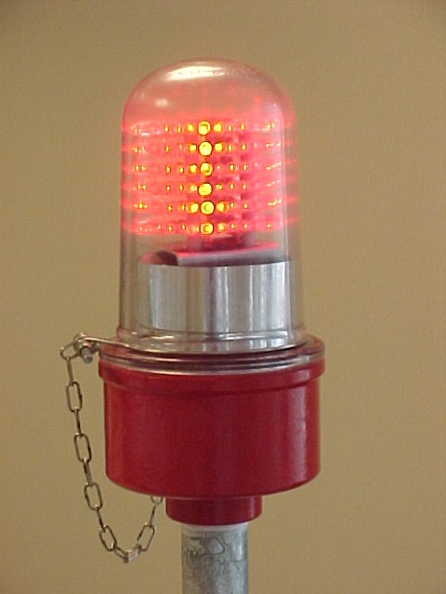


April - 2002

Caution : Please do not attempt to open the lamp head as there is no servicable part inside!

INDEX

- Parts of Air Obstruction Light System

  - Air Obstruction Light
  - Alarm Box

- Installation Steps

  - Connection to Alarm Box
  - Connection to Power Box
  - Fixing the Air Obstruction Light to the tower

- Technical Features

- Parts of Air Obstruction Light System

Air Obstruction Light System is mainly composed of below parts:

  - Air Obstruction Light

Consist of the lamp head, internal pedestal, LED group, support pipe and power box. To be installed at the top of the tower.

  - Alarm Box

Consist of the alarm and feeding circuitry. To be installed in the system room.

- Installation Steps

Before commencing any installation work, make sure that a two pairs of preferably at least 0,75mm cable is already deployed between the system room and the point where the Air Obstruction Light will be installed. Check the cable with a cable tester to make sure that it is in good shape.

2.1 Connection to Alarm Box

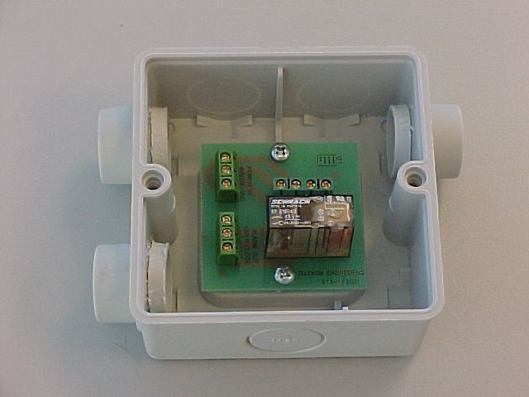
There are three groups of connection points as follows:
Figure 1

i) Power In
ii) Lamp Out
iii) Alarm Out.

2.1.1 “-48V” point at the “Power In” block must be connected to the –48VDC (live) pole of the DC Power Supply using an appropriate circuit breaker with a minimum rating of 2 amps. This circuit breaker must be kept open contact until the end of the installation!

2.1.2 “0V” point at the “Power In” block must be connected to the positive (common) pole of the DC Power Supply.

2.1.3 The system shall be grounded from the “GND” point at the “Power In” block.

2.1.4 If the alarm option is required, one of the contacts in the “Alarm Out” block must be connected to the alarm interface of the Client which might be an alarm box, a BTS cabinet, a digital R/L unit or any other transmitting device. There are two contacts using one common point: “OPEN” and “CLOSE”, to be selected accordingly with the Alarm System design.

2.1.5 Two pairs of cable shall be connected to the four points at the “Lamp Out” block. Note that the corresponding ends of those cables must be connected to the “Power Box” at the top observing the same order (see section 2.2).

2.2 Connection to Power Box
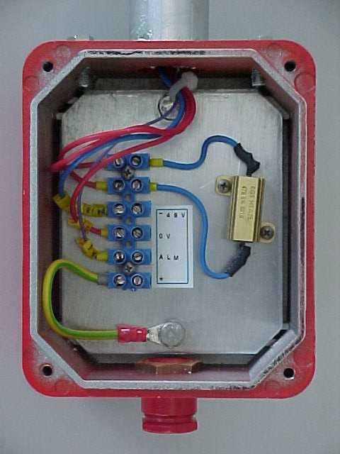
Figure 2
There are four connection points as follows:

i) -48V
ii) 0V
iii) ALM (Alarm)
iv) GND

    - Uncover the box.
    - Connect the cable coming from the “Alarm Box” matching the connection points as shown below:

ALARM BOX  (Lamp Out) | POWER BOX
-48V | -48V
0V | 0V
GND
AL | ALM

    - Cover the box and screw four corners firmly.

2.3iFixing the Air Obstruction Light to the tower

To fix the Air Obstruction Light, use the connection part on the support pipe with a suitable pipe clip which fits the tower body.

- Technical Features

Operating Voltage | -48VDC standart (12VDC, 24VDC, 220AC optional)
Nominal Light Output | 270 cd red
Power Consumption | 16.7 W
Life Expectancy | >20,000 hours
Dimensions | 80 cm high including the glass, support pipe and the alarm box
Weight | 3kg
Operating Temperature | -20°C...+70°C
Protection | IP67
Alarm | Optional

